FOR IMMEDIATE RELEASE:
Toomsuba Resident Wins Statewide Home Care Recognition
The Mississippi Association for Home Care (MAHC) is proud to announce that Twannie Scott of Toomsuba, Mississippi has received statewide recognition as the recipient of the 2018 Home Health Aide of the Year Award.
Ms. Scott works for Kindred at Home in Meridian as a home health aide. Scott is described as having a servant’s heart. Her patients have nothing but the best compliments for her, working at each patient’s pace and not her own. The patients feel as though she is there for them and them alone, as she does all she can to make sure their needs are met.
The Home Health Aide of the Year award is one of MAHC’s most prestigious awards. The award recognizes the value of the home health aide to the home care industry and to the patients that they serve. Home Health aides are the backbone of the home health care delivery system and are vital to patient care.
The Mississippi Association for Home Care is a non-profit membership organization dedicated to operating for the benefit of member home health agencies, home heath related agencies and the benefit of the public in fostering and maintaining high standards of home health care.
For more information, contact Mary Lea Nations, Executive Director of MAHC at 601-924-2275, or mnations@mahc.org.

Images Below-
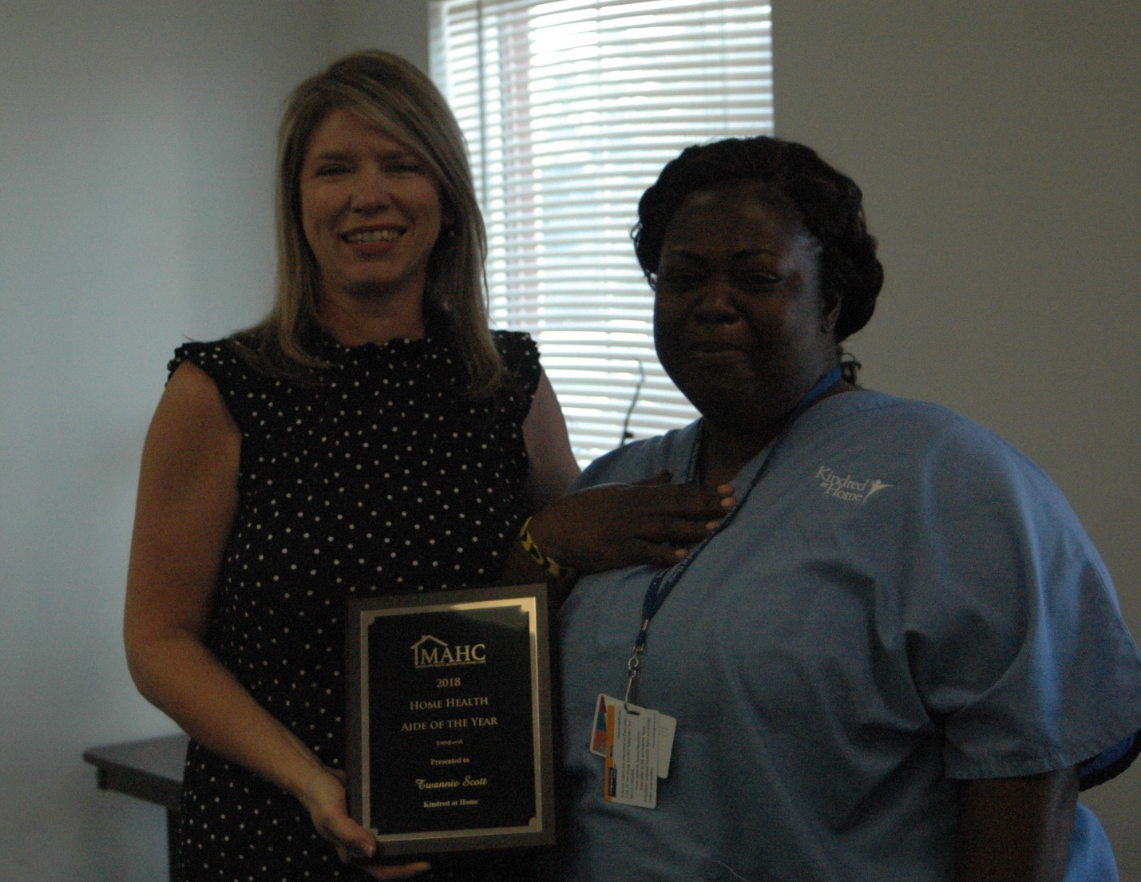
Becky Knight, MAHC President presents 2018 Home Health Aide of the Year Award to Twannie Scott.

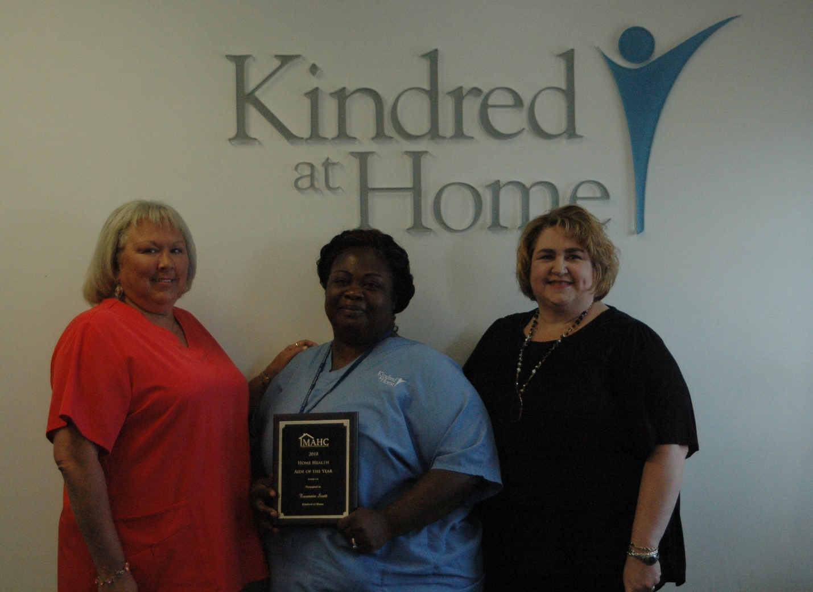
Mary Ann Coghlan, RN, Manager of Clinical Practice – Kindred at Home Meridian, Twannie Scott, MAHC Home Health Aide of the Year 2018, Kim Binh, RN, Executive Director – Kindred at Home Meridian.

